Protect
Your
Family
From
Lead in
Your
Home

United States
Environmental
Protection Agency
EPA
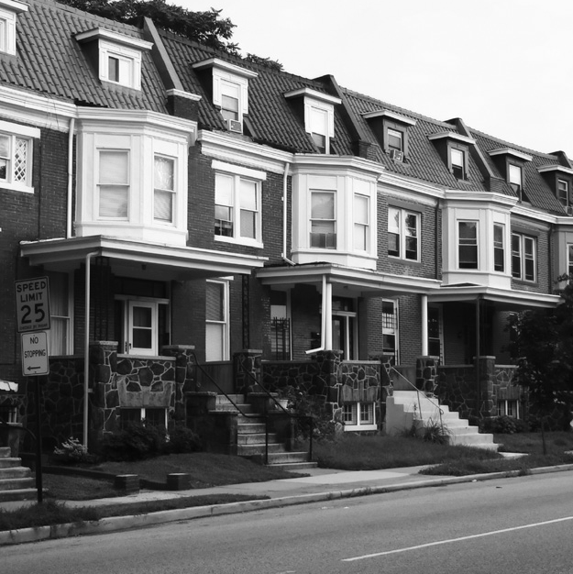
United States Department of Housing and Urban Development
United States
Consumer Product
Safety Commission
Are You Planning to Buy or Rent a Home Built Before 1978?

Did you know that many homes built before 1978 have lead-based paint? Lead from paint, chips, and dust can pose serious health hazards.

Read this entire brochure to learn:
- How lead gets into the body
- About health effects of lead
- What you can do to protect your family
- Where to go for more information

Before renting or buying a pre-1978 home or apartment, federal law requires:
- Sellers must disclose known information on lead-based paint or lead- based paint hazards before selling a house.
- Real estate sales contracts must include a specific warning statement about lead-based paint. Buyers have up to 10 days to check for lead.
- Landlords must disclose known information on lead-based paint and lead-based paint hazards before leases take effect. Leases must include a specific warning statement about lead-based paint.

If undertaking renovations, repairs, or painting (RRP) projects in your pre-1978 home or apartment:
- Read EPA’s pamphlet, The Lead-Safe Certified Guide to Renovate Right, to learn about the lead-safe work practices that contractors are required to follow when working in your home.

Simple Steps to Protect Your Family from Lead Hazards

If you think your home has lead-based paint:
- Don’t try to remove lead-based paint yourself.
- Always keep painted surfaces in good condition to minimize deterioration.
- Get your home checked for lead hazards. Find a certified inspector or risk assessor at epa.gov/lead.
- Talk to your landlord about fixing surfaces with peeling or chipping paint.
- Regularly clean floors, window sills, and other surfaces.
- Take precautions to avoid exposure to lead dust when remodeling.
- When renovating, repairing, or painting, hire only EPA- or state- approved Lead-Safe
certified renovation firms.
- Before buying, renting, or renovating your home have it checked for lead-based paint.
- Consult your health care provider about testing your children for lead. Your pediatrician can
check for lead with a simple blood test.
- Wash children’s hands, bottles, pacifiers, and toys often.
- Make sure children eat healthy, low-fat foods high in iron, calcium, and vitamin C.
- Remove shoes or wipe soil off shoes before entering your house.

Lead Gets into the Body in Many Ways

Adults and children can get lead into their bodies if they:
- Breathe in lead dust (especially during activities such as renovations, repairs, or painting that disturb painted surfaces).
- Swallow lead dust that has settled on food, food preparation surfaces, and other places.
- Eat paint chips or soil that contains lead.
Lead is especially dangerous to children under the age of 6:
- At this age, children’s brains and nervous systems are more
sensitive to the damaging effects of lead.
- Children’s growing bodies absorb more lead.
- Babies and young children often put their hands
and other objects in their mouths. These objects can have lead dust on them.

Women of childbearing age should know that lead is dangerous to a developing fetus.
- Women with a high lead level in their system before or during pregnancy risk exposing the fetus to lead through the placenta during fetal development.

Health Effects of Lead

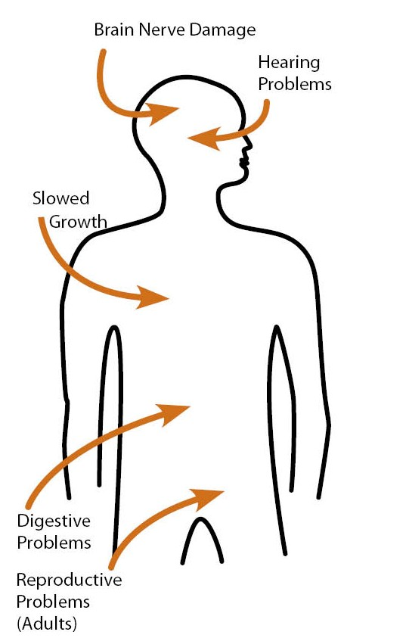Lead affects the body in many ways. It is important to know that even exposure to low levels of lead can severely harm children.

In children, exposure to lead can cause:
- Nervous system and kidney damage
- Learning disabilities, attention deficit disorder, and decreased intelligence
- Speech, language, and behavior problems
- Poor muscle coordination
- Decreased muscle and bone growth
- Hearing damage

While low-lead exposure is most common, exposure to high amounts of lead can
Have devastating effects on children, including seizures, unconsciousness, and,
in some cases, death.

Although children are especially susceptible to lead exposure, lead can be dangerous for adults, too.

In adults, exposure to lead can cause:
- Harm to a developing fetus
- Increased chance of high blood pressure during pregnancy
- Fertility problems (in men and women)
- High blood pressure
- Digestive problems
- Nerve disorders
- Memory and concentration problems
- Muscle and joint pain
Check Your Family for Lead

Get your children and home tested if you think your home has lead.

Children’s blood lead levels tend to increase rapidly from 6 to 12 months of age, and tend to peak at 18 to 24 months of age.

Consult your doctor for advice on testing your children. A simple blood test can detect lead. Blood lead tests are usually recommended for:
- Children at ages 1 and 2
- Children or other family members who have been exposed to high levels of lead
- Children who should be tested under your state or local health screening plan

Your doctor can explain what the test results mean and if more testing will be needed.

Where Lead-Based Paint Is Found

In general, the older your home or childcare facility, the more likely it has lead-based paint. “Lead-based paint” is currently defined by the federal government as paint with lead levels greater than or equal to 1.0 milligram per square centimeter (mg/cm), or more than 0.5% by weight.

Many homes, including private, federally assisted, federally owned housing, and childcare facilities built before 1978 have lead-based paint. In 1978, the federal government banned consumer uses of lead- containing paint. “Lead-containing paint” is currently defined by the federal government as lead in new dried paint in excess of 90 parts per million (ppm) by weight.

Learn how to determine if paint is lead-based paint under “Checking Your Home for Lead” later in this document.

Lead can be found:
- In homes and childcare facilities in the city, country, or suburbs;
- In private and public single-family homes and apartments;
- On surfaces inside and outside of the house; and
- In soil around a home. (Soil can pick up lead from exterior paint or other sources, such as past use of leaded gas in cars.)

Learn more about where lead is found at epa.gov/lead.

Identifying Lead-Based Paint and Lead-Based Paint Hazards

Deteriorating lead-based paint (peeling, chipping, chalking, cracking, or damaged paint) is a hazard and needs immediate attention. Lead-based paint may also be a hazard when found on surfaces that children can chew or that get a lot of wear and tear, such as:
- On windows and window sills
- Doors and door frames
- Stairs, railings, banisters, and porches

Lead-based paint is usually not a hazard if it is in good condition and if it is not on an impact or friction surface like a window.

Lead dust can form when lead-based paint is scraped, sanded, or heated. Lead dust also forms when painted surfaces containing lead bump or rub together. Lead paint chips and dust can get on surfaces and objects that people touch. Settled lead dust can reenter the air when the home is vacuumed or swept, or when people walk through it. EPA currently defines the following levels of lead in dust as hazardous:
- 40 micrograms per square foot (μg/ft2) and higher for floors, including carpeted floors
- 250 μg/ft2 and higher for interior window sills

Lead in soil can be a hazard when children play in bare soil or when people bring soil into the house on their shoes. EPA currently defines the following levels of lead in soil as hazardous:
- 400 parts per million (ppm) and higher in play areas of bare soil
- 1,200 ppm (average) and higher in bare soil in the remainder of the yard

Remember, lead from paint chips—which you can see—and lead dust—which you may not be able to see—both can be hazards. The only way to find out if paint, dust, or soil lead hazards exist is to test for them. The next section describes how to do this.

Checking Your Home for Lead

You can get your home tested for lead in several different ways:
- A lead-based paint inspection tells you if your home has lead- based paint and where it is located. It won’t tell you whether your home currently has lead hazards. A trained and certified testing professional, called a lead-based paint inspector, will conduct a paint inspection using methods, such as:
- Portable x-ray fluorescence (XRF) machine
- Lab tests of paint samples

- A risk assessment tells you if your home currently has any lead hazards from lead in paint,
dust, or soil. It also tells you what actions to take to address any hazards. A trained and
certified testing professional, called a risk assessor, will:
- Sample paint that is deteriorated on doors, windows, floors, stairs, and walls
- Sample dust near painted surfaces and sampling bare soil in the yard
- Get lab tests of paint, dust, and soil samples

- A combination inspection and risk assessment tells you if your home has any lead-based
paint and if your home has any lead hazards, and where both are located.
Be sure to read the report provided to you after your inspection or risk assessment is completed, and ask questions about anything you do not understand.

In preparing for renovation, repair, or painting work in a pre-1978 home, Lead-Safe Certified renovators may:
- Take paint chip samples to determine if lead-based paint is present in the area planned for renovation and send them to an EPA-recognized lead lab for analysis. In housing receiving federal assistance, the person collecting these samples must be a certified lead-based paint inspector or risk assessor.
- Use EPA-recognized tests kits to determine if lead-based paint is absent (but not in housing receiving federal assistance)
- Presume that lead-based paint is present and use lead-safe work practices

There are state and federal programs in place to ensure that testing is done safely, reliably, and effectively. Contact your state or local agency for more information, visit epa.gov/lead, or call 1-800-424-LEAD (5323) for a list of contacts in your area. Hearing-or speech challenged individuals may access this number through TTY by calling the Federal Relay Service at 1-800-877-8399.

What You Can Do Now to Protect Your Family

If you suspect that your house has lead-based paint hazards, you can take some immediate steps to reduce your family’s risk:
- If you rent, notify your landlord of peeling or chipping paint.
- Keep painted surfaces clean and free of dust. Clean floors, window frames, window sills, and other surfaces weekly. Use a mop or sponge with warm water and a general all-purpose cleaner. (Remember: never mix ammonia and bleach products together because they can form a dangerous gas.)
- Carefully clean up paint chips immediately without creating dust.
- Thoroughly rinse sponges and mop heads often during cleaning of dirty
or dusty areas, and again afterward.
- Wash your hands and your children’s hands often, especially before they eat
and before nap time and bed time.
- Keep play areas clean. Wash bottles, pacifiers, toys, and stuffed animals
regularly.
- Keep children from chewing window sills or other painted surfaces, or eating soil.
- When renovating, repairing, or painting, hire only EPA- or state- approved Lead-Safe Certified renovation firms.
- Clean or remove shoes before entering your home to avoid tracking in lead from soil.
- Make sure children eat nutritious, low-fat meals high in iron, and calcium,
such as spinach and dairy products. Children with good diets absorb less lead.
Reducing Lead Hazards

Disturbing lead-based paint or removing lead improperly can increase the hazard to your family by spreading even more lead dust around the house.
- In addition to day-to-day cleaning and good nutrition, you can temporarily reduce lead-based paint hazards by taking actions, such as repairing damaged painted surfaces and planting grass to cover lead- contaminated soil. These actions are not permanent solutions and will need ongoing attention.

- You can minimize exposure to lead when renovating, repairing, or painting, by hiring an EPA- or state- certified renovator who is trained in the use of lead-safe work practices. If you are a do-it-yourselfer, learn how to use lead–safe work practices in your home.

- To remove lead hazards permanently, you should hire a certified lead abatement contractor. Abatement (or permanent hazard elimination) methods include removing, sealing, or enclosing lead-based paint with special materials. Just painting over the hazard with regular paint is not permanent control.

Always use a certified contractor who is trained to address lead hazards safely.
- Hire a Lead-Safe Certified firm to perform renovation, repair, or painting (RRP) projects that disturb painted surfaces.

- To correct lead hazards permanently, hire a certified lead abatement professional. This will ensure your contractor knows how to work safely and has the proper equipment to clean up thoroughly.

Certified contractors will employ qualified workers and follow strict safety rules as set by their state or by the federal government.

If your home has had lead abatement work done or if the housing is receiving federal assistance, once the work is completed, dust cleanup activities must be conducted until clearance testing indicates that lead dust levels are below the following levels:
- 40 micrograms per square foot (μg/ft2) for floors, including carpeted floors
- 250 μg/ft2 for interior windows sills
- 400 μg/ft2 for window troughs

For help in locating certified lead abatement professionals in your area, call your state or local agency or visit epa.gov/lead, or call 1-800-424-LEAD.

Renovating, Remodeling, or Repairing (RRP) a Home with Lead-Based Paint

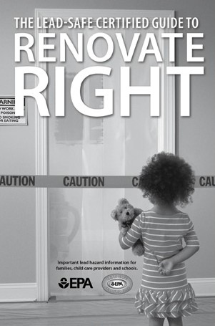If you hire a contractor to conduct renovation, repair, or painting (RRP) projects in your pre-1978 home or childcare facility (such as pre-school and kindergarten), your contractor must:
- Be a Lead-Safe Certified firm approved by EPA or an EPA-authorized state program;
- Use qualified trained individuals (Lead-Safe Certified renovators) who follow
specific lead-safe work practices to prevent lead contamination; and
- Provide a copy of EPA’s lead hazard information document, The Lead-Safe Certified
Guide to Renovate Right

RRP contractors working in pre-1978 homes and childcare facilities must follow
lead-safe work practices that:
- Contain the work area. The area must be contained so that dust and debris do not
escape from the work area. Warning signs must be put up, and plastic or other
impermeable material and tape must be used.

- Avoid renovation methods that generate large amounts of lead-contaminated dust. Some methods generate so much lead- contaminated dust that their use is prohibited. They are:
- Open-flame burning or torching
- Sanding, grinding, planing, needle gunning, or blasting with power tools and equipment not equipped with a shroud and HEPA vacuum attachment and
- Using a heat gun at temperatures greater than 1100°F

- Clean up thoroughly. The work area should be cleaned up daily. When all the work is done, the area must be cleaned up using special cleaning methods.

- Dispose of waste properly. Collect and seal waste in a heavy duty bag or sheeting. When transported, ensure that waste is contained to prevent release of dust and debris.

To learn more about EPA’s requirements for RRP projects visit epa.gov/getleadsafe, or read The Lead-Safe Certified Guide to Renovate Right.

Other Sources of Lead

While paint, dust, and soil are the most common sources of lead, other lead sources also exist:
- Drinking water. Your home might have plumbing with lead or lead solder. You cannot see, smell, or taste lead, and boiling your water will not get rid of lead. If you think your plumbing might contain lead:
- Use only cold water for drinking and cooking.
- Run water for 15 to 30 seconds before drinking it, especially if you have not used your water for a few hours.
- Call your local health department or water supplier to find out about testing your water, or visit epa.gov/lead for EPA’s lead in drinking water information

- Lead smelters or other industries that release lead into the air.

- Your job. If you work with lead, you could bring it home on your body or clothes. Shower and change clothes before coming home. Launder your work clothes separately from the rest of your family’s clothes.

- Hobbies that use lead, such as making pottery or stained glass, or refinishing furniture. Call your local health department for information about hobbies that may use lead.

- Old toys and furniture may have been painted with lead-containing paint. Older toys and other children’s products may have parts that contain lead. In 1978, the federal government banned toys, other children’s products, and furniture with lead-containing paint (16 CFR 1303). In 2008, the federal government banned lead in most children’s products. The federal government currently bans lead in excess of 100 ppm by weight in most children’s products (76 FR 44463).

- Food and liquids cooked or stored in lead crystal or lead-glazed pottery or porcelain may contain lead.

- Folk remedies, such as “greta” and “azarcon,” used to treat an upset stomach.

IMPORTANT!
- Lead From Paint, Dust, and Soil in and Around Your Home Can Be Dangerous if Not Managed Properly.

- Children under 6 years old are most at risk for lead poisoning in your home.

- Lead exposure can harm young children, babies, and fetuses even before they are born.

- Homes, schools, and child care facilities built before 1978 are likely to contain lead-based paint.

- Even children who seem healthy may have dangerous levels of lead in their bodies.

- Disturbing surfaces with lead-based paint or removing lead-based paint improperly can increase the
danger to your family.

- People can get lead into their bodies by breathing or swallowing lead dust, or by eating soil or
paint chips containing lead.

- People have many options for reducing lead hazards. Generally, lead-based paint that is in good condition is not a hazard.
For More Information

The National Lead Information Center
Learn how to protect children from lead poisoning and get other information about lead hazards on the Web at epa.gov/lead and hud.gov/lead, or call 1-800-424-LEAD (5323).

EPA’s Safe Drinking Water Hotline
For information about lead in drinking water, call 1-800-426-4791, or visit epa.gov/lead for information about lead in drinking water.

Consumer Product Safety Commission (CPSC) Hotline
For information on lead in toys and other consumer products, or to report an unsafe consumer product or a product-related injury, call 1-800-638-2772, or visit CPSC’s website at cpsc.gov or saferproducts.gov.

State and Local Health and Environmental Agencies
Some states, tribes, and cities have their own rules related to lead-based paint. Check with your local agency to see which laws apply to you. Most agencies can also provide information on finding a lead abatement firm in your area, and on possible sources of financial aid for reducing lead hazards. Receive up-to-date address and phone information for your state or local contacts on the Web at epa.gov/lead, or contact the National Lead Information Center at 1-800-424-LEAD.

Hearing- or speech-challenged individuals may access any of the phone numbers in this brochure
through TTY by calling the toll-free Federal Relay Service at 1-800-877-8339.

U. S. Environmental Protection Agency (EPA) Regional Office

The mission of EPA is to protect human health and the environment. Your Regional EPA Office can provide further information regarding regulations and lead protection programs.

Region 3 (Delaware, Maryland, Pennsylvania, Virginia, DC, West Virginia)
Regional Lead Contact
U.S. EPA Region 3 1650 Arch Street
Philadelphia, PA 19103
(215) 814-2088

Consumer Product Safety Commission (CPSC)

The CPSC protects the public against unreasonable risk of injury from consumer products through education, safety standards activities, and enforcement. Contact CPSC for further information regarding consumer product safety and regulations.

CPSC www.cpsc.gov or www.saferproducts.gov
4330 East West Highway
Bethesda, MD 20814-4421
1-800-638-2772
U. S. Department of Housing and Urban Development (HUD)

HUD’s mission is to create strong, sustainable, inclusive communities and quality affordable homes for all. Contact HUD’s Office of Healthy Homes and Lead Hazard Control for further information regarding the Lead Safe Housing Rule which protects families in pre-1978 assisted housing and the lead hazard control and research grant programs.

HUD hud.gov/offices/lead/
451 Seventh Street, SW, Room 8236
Washington, DC 20410-3000
(202) 402-7698

This document is in the public domain. It may be produced by an individual or organization without permission. Information provided in this booklet is based upon current scientific and technical understanding of the issues presented and is reflective of the jurisdictional boundaries established by the statues governing the co-authoring agencies. Following the advice given will not necessarily provide complete protection in all situations or against all health hazards that can be caused by lead exposure.

U. S. EPA
Washington DC 20460

U.S. CPSC
Bethesda, MD 20814

U. S. HUD
Washington DC 20410

EPA-747-12-001
December 2012

